Day 8 Homework

Task 1 (Easy)
When the form loads, if Category = Network, show a message: “Network team will handle this”
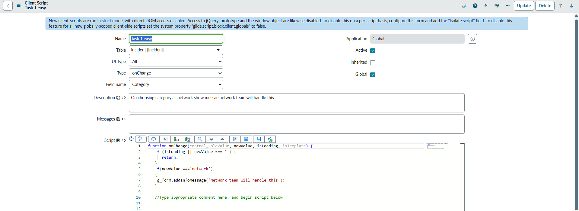

Task 2 (Easy)
When Priority = High, make the Description field mandatory
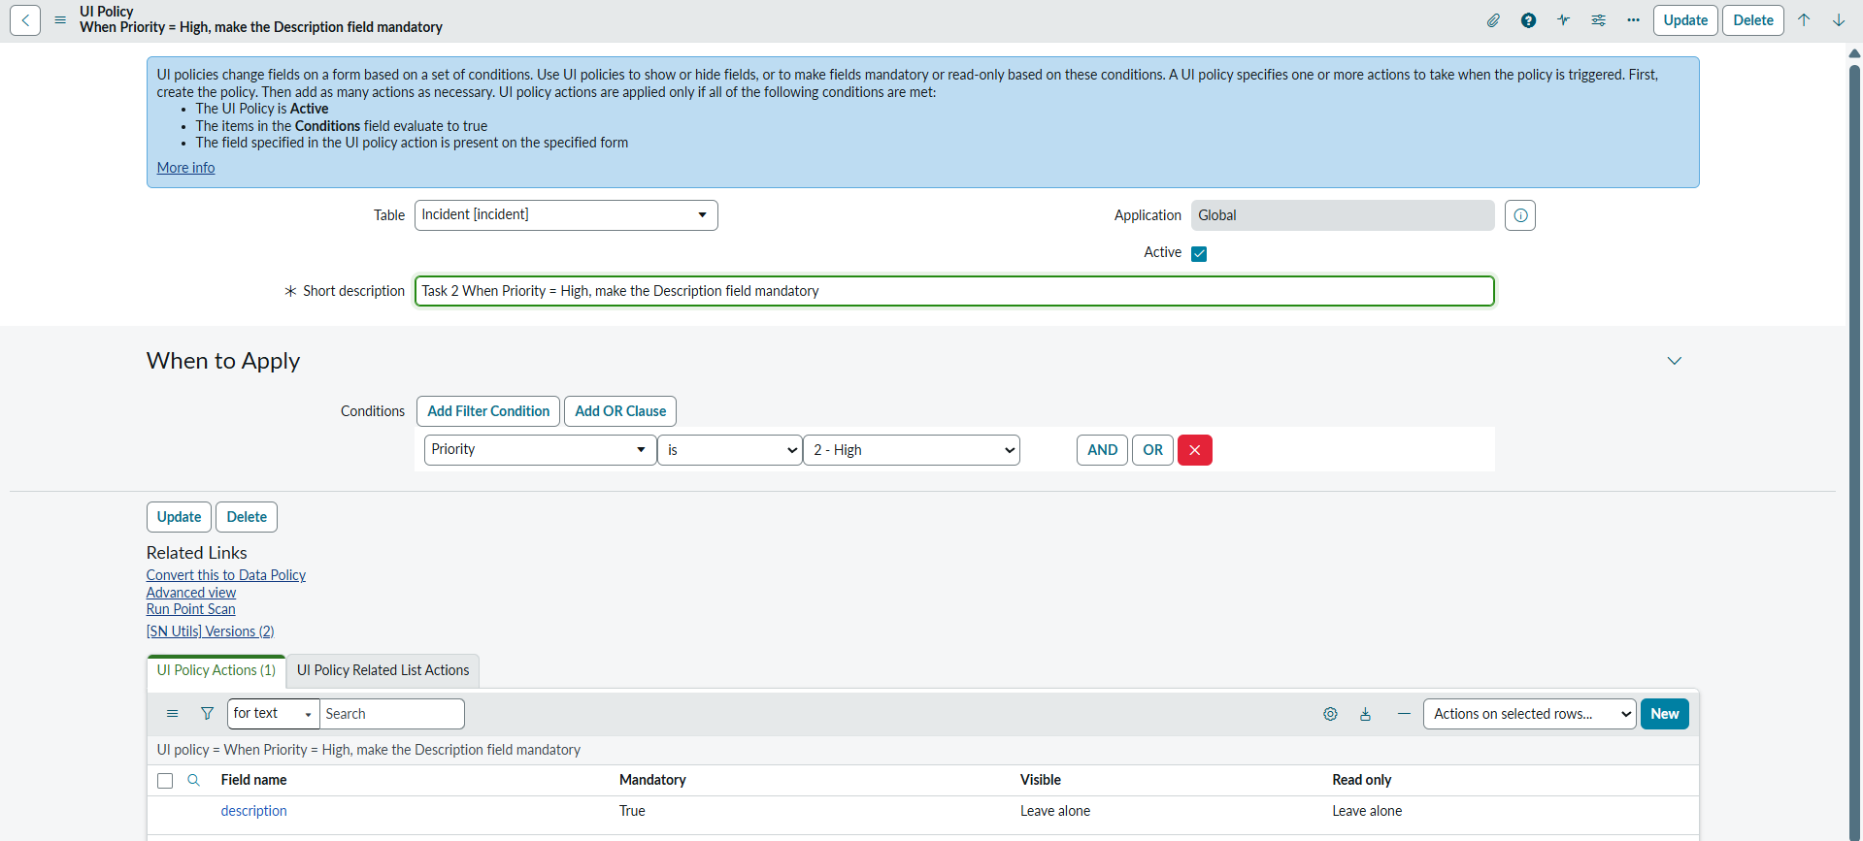

Task 3 (Easy)
When State = Closed, make all fields read-only
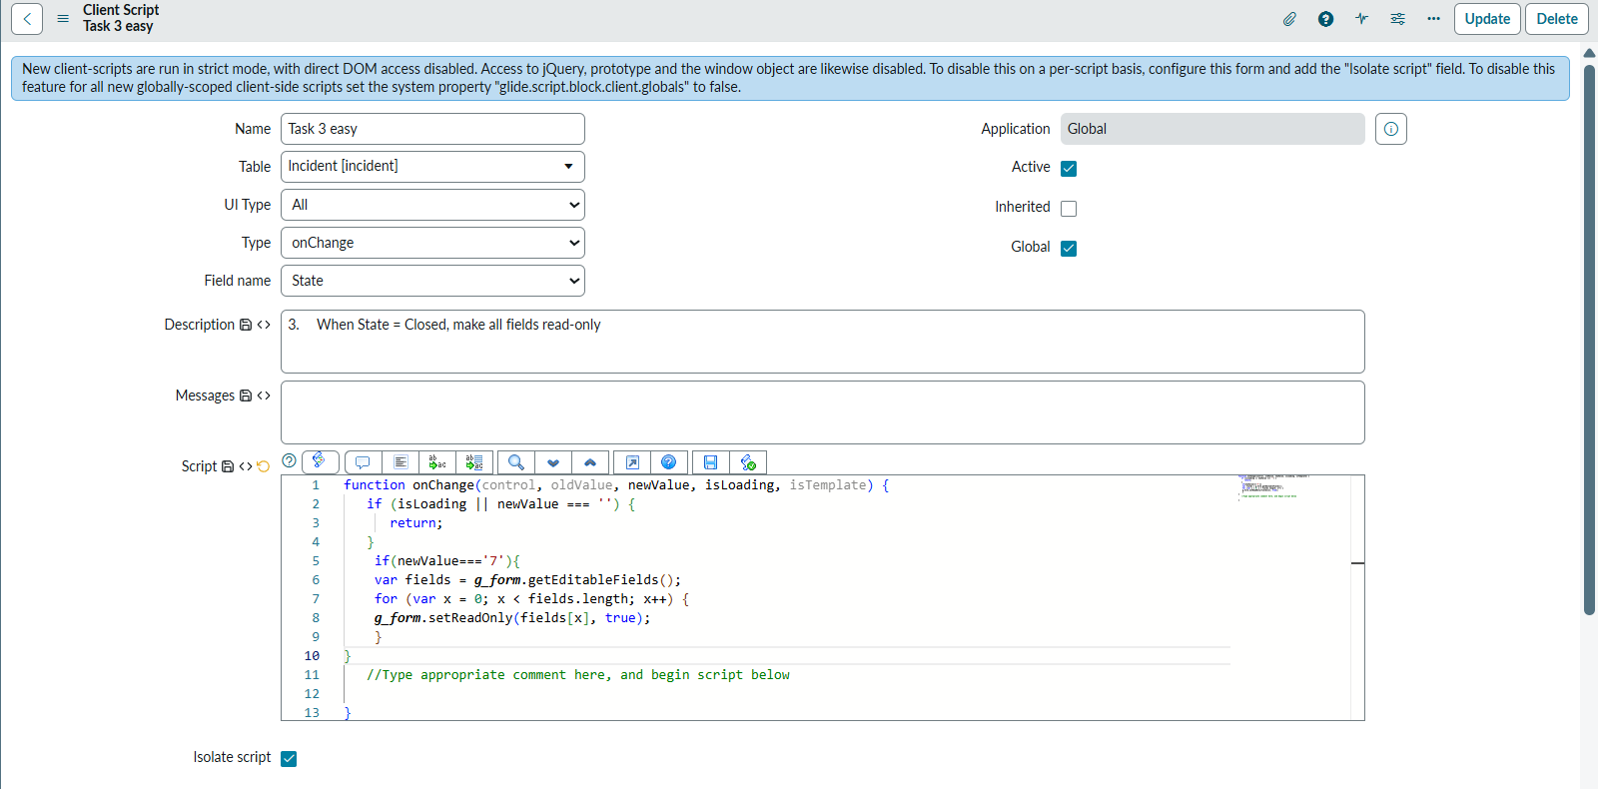

Task 4 (Easy)
When Category is cleared, clear the Subcategory field automatically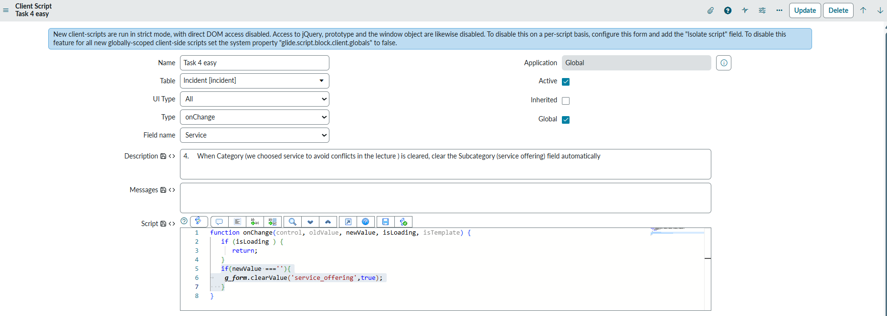

Task 5 (Easy)
When Urgency = Low, hide the Impact field.
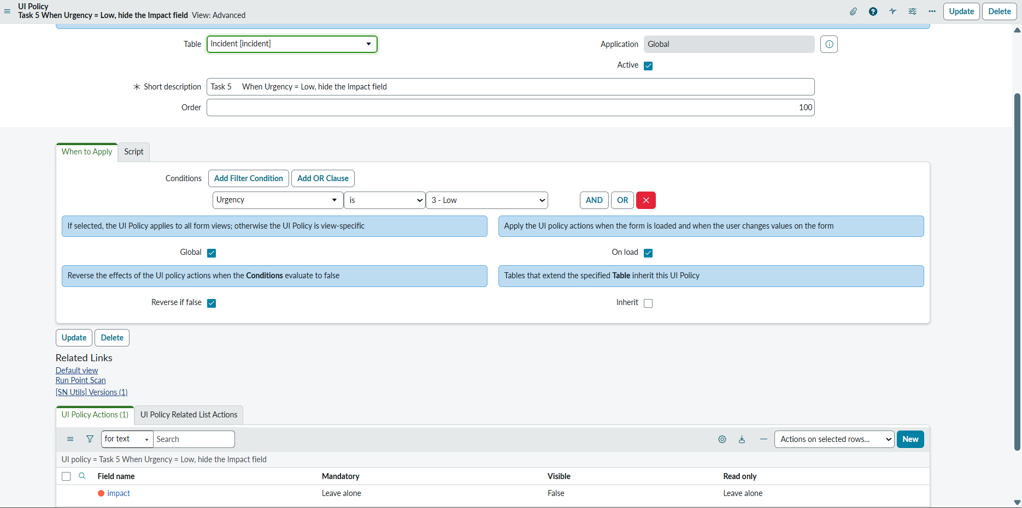

Task 6 (Medium)
When Caller is selected, auto-fill a custom field like Department using Caller details
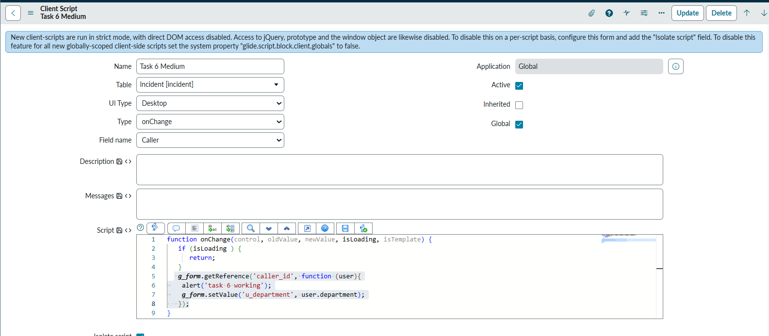

Task 7 (Medium)
If the Caller is VIP, automatically set: Priority = High, Urgency = High 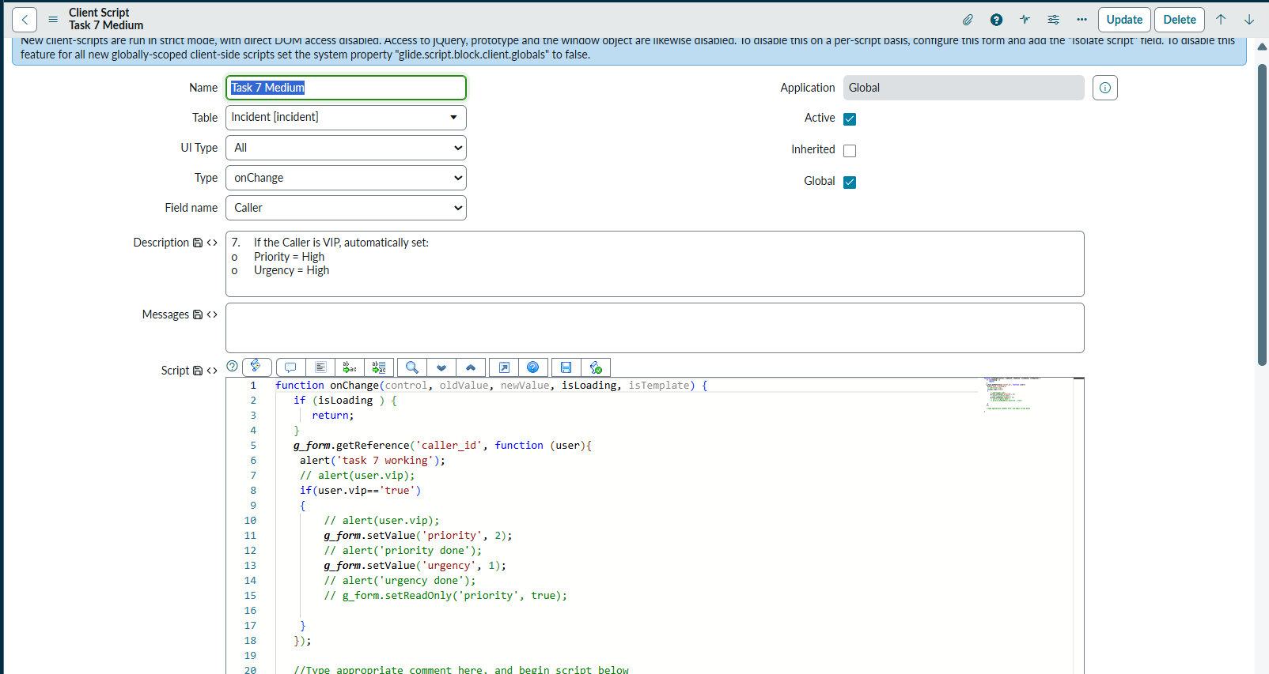

Task 8 (Medium)
When Category = Software, show Assignment Group field, otherwise hide it.
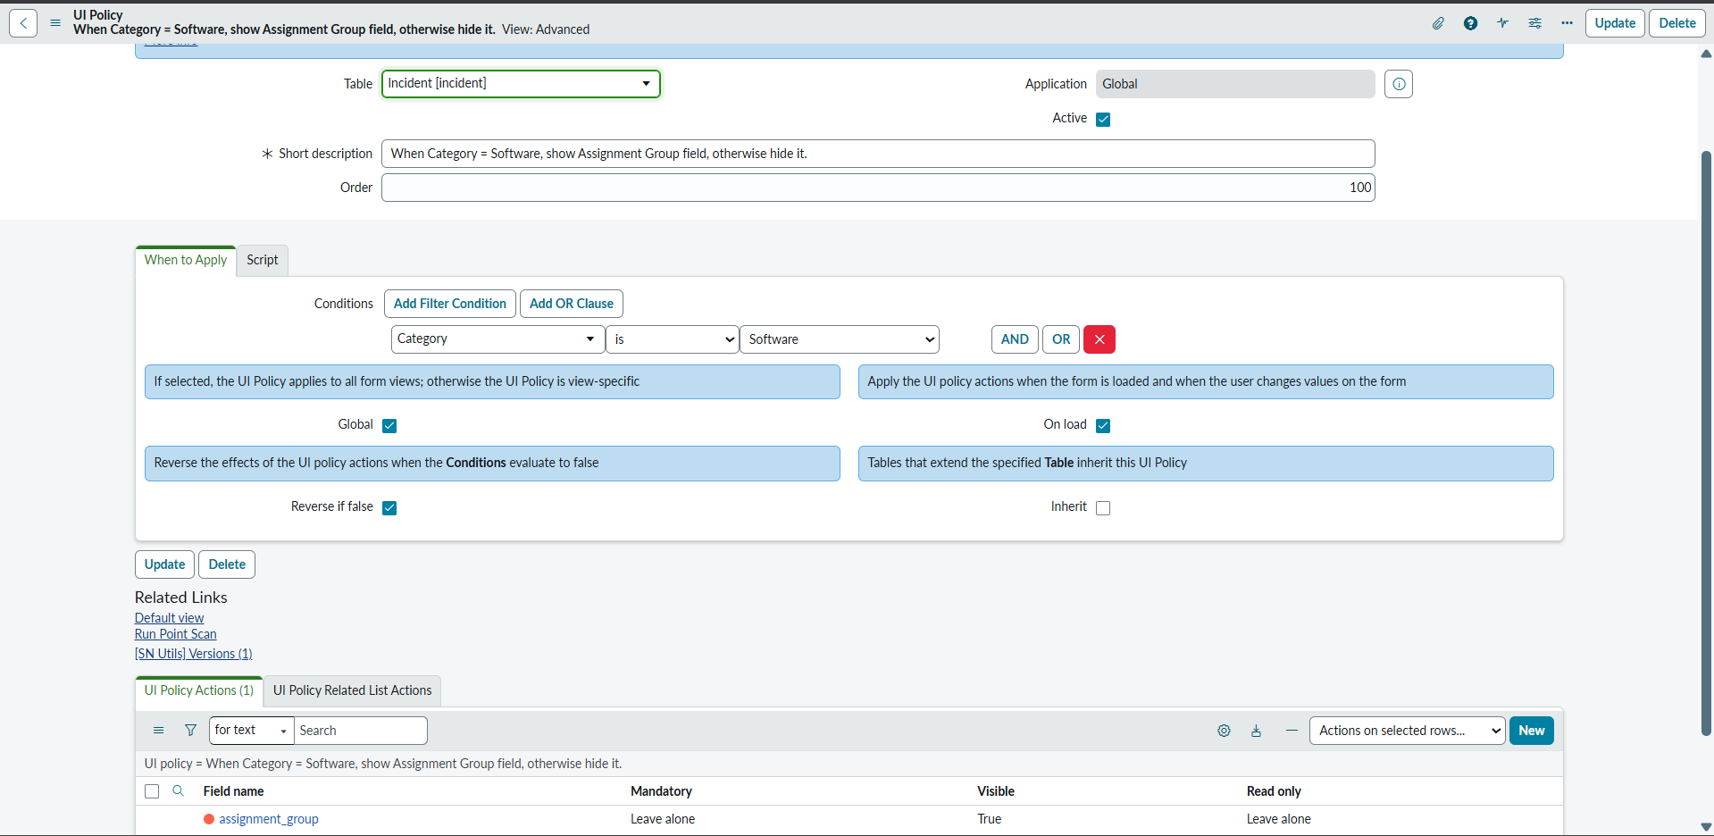

Task 9 (Medium)
When Short Description is empty, prevent user from submitting the form.
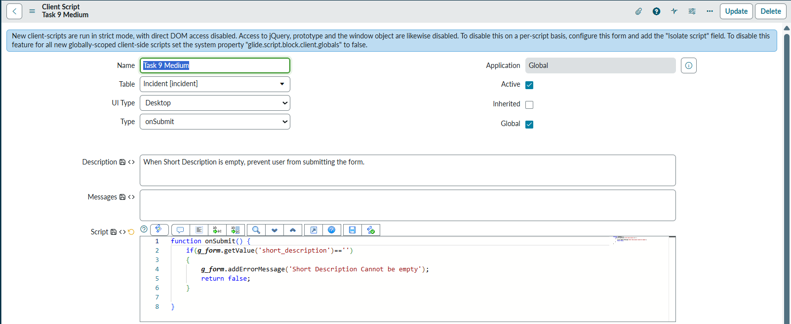

Task 10 (Medium)
When State changes to In Progress, show a message: “Work has started on this incident”.
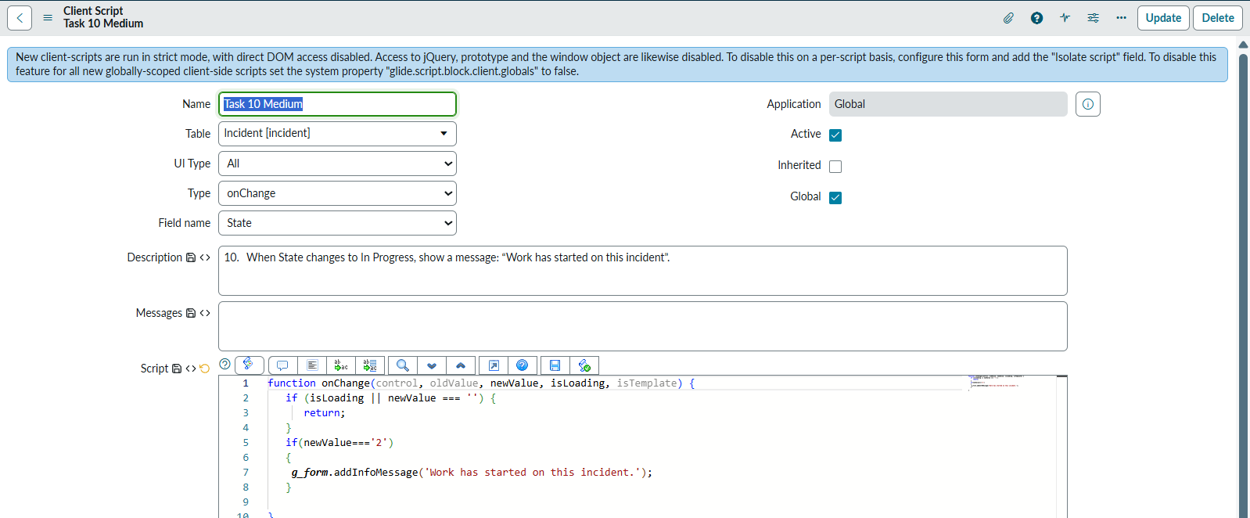

Task 11 (Important)
When a Caller is selected, fetch the user’s Location and display it in a field. (Changed location with email)
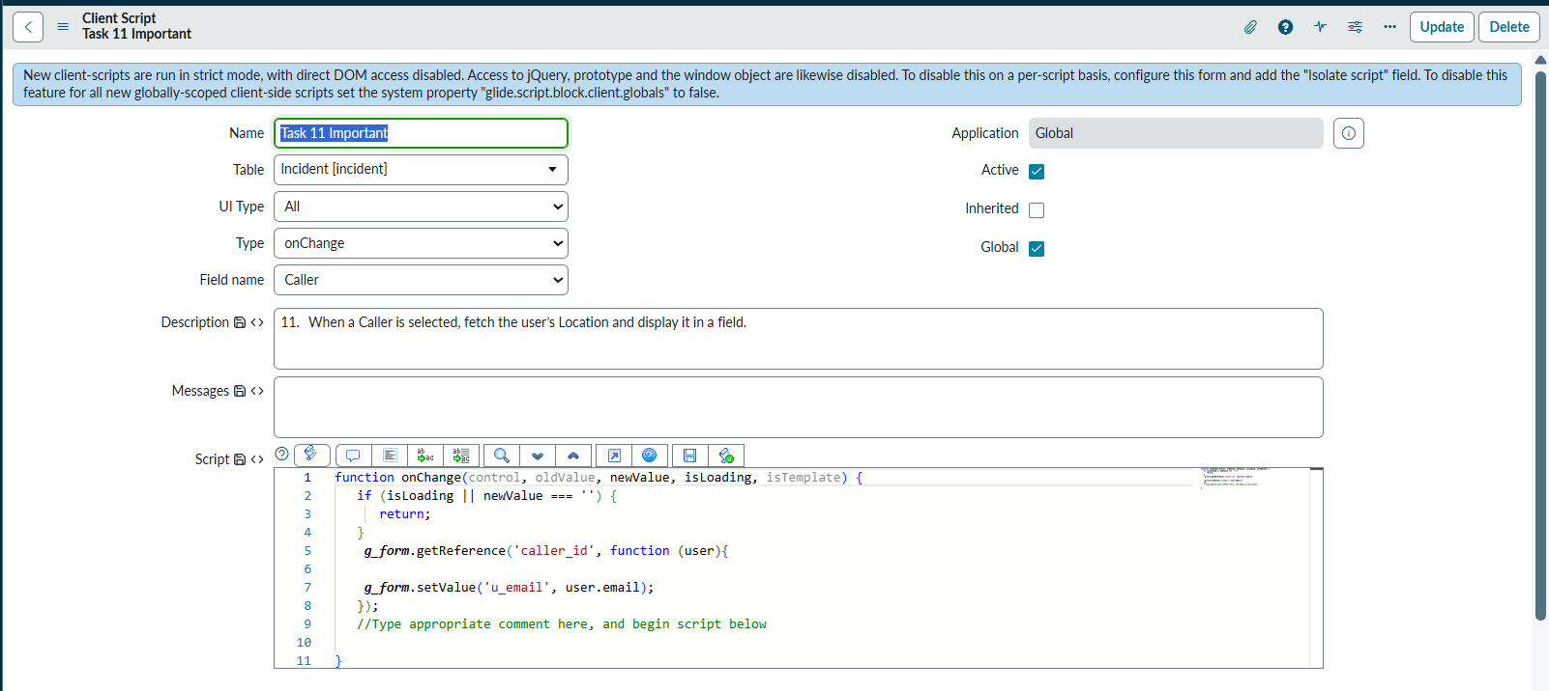

Task 12 (Important)
If the Caller belongs to HR department, make Priority read-only.
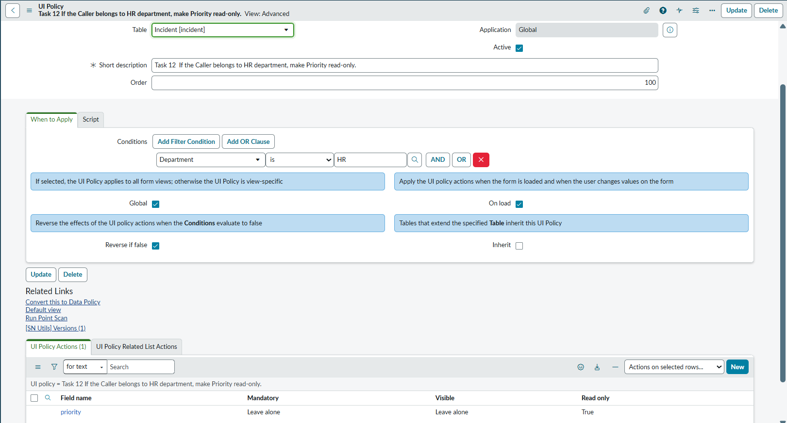

Task 13 (Important)
When Caller is inactive, show an error message and prevent form submission
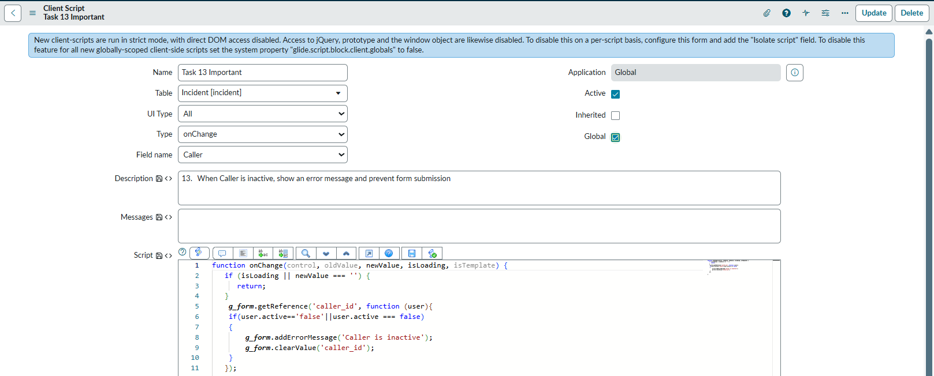

Task 14 (Important)
If Caller’s email contains “admin”, display a warning message
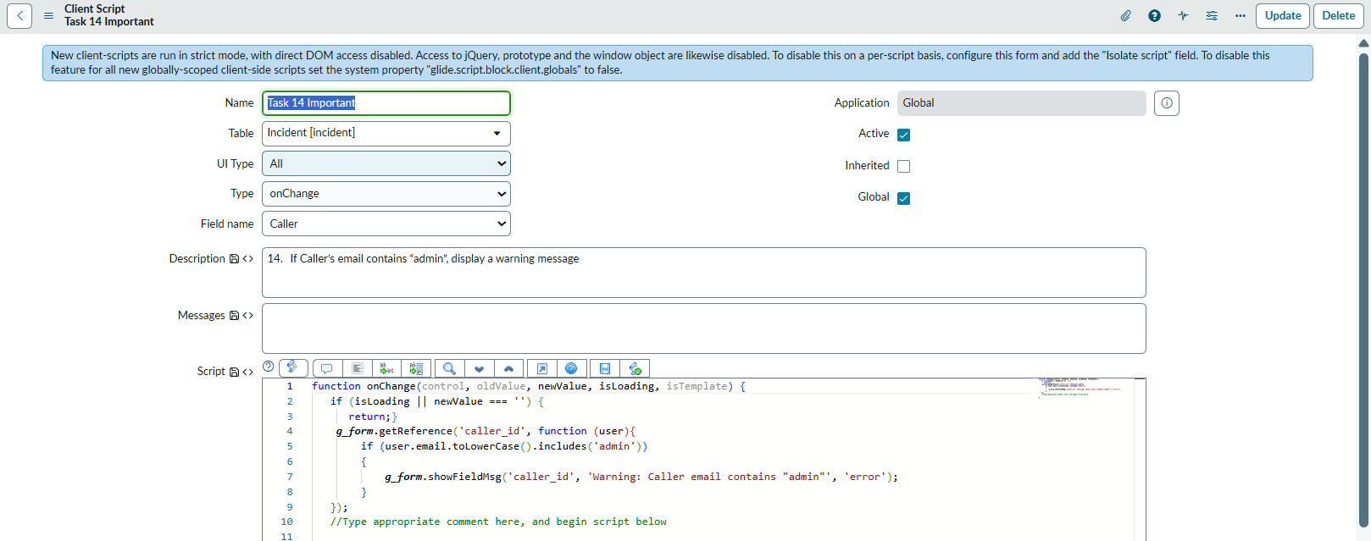

Task 15 (Important)
When Caller’s department is IT, automatically assign the incident to “IT Support Group”.
(Created conflict with Task 8 so I made Task 8 Inactive, also used IT Teams Instead of support group)
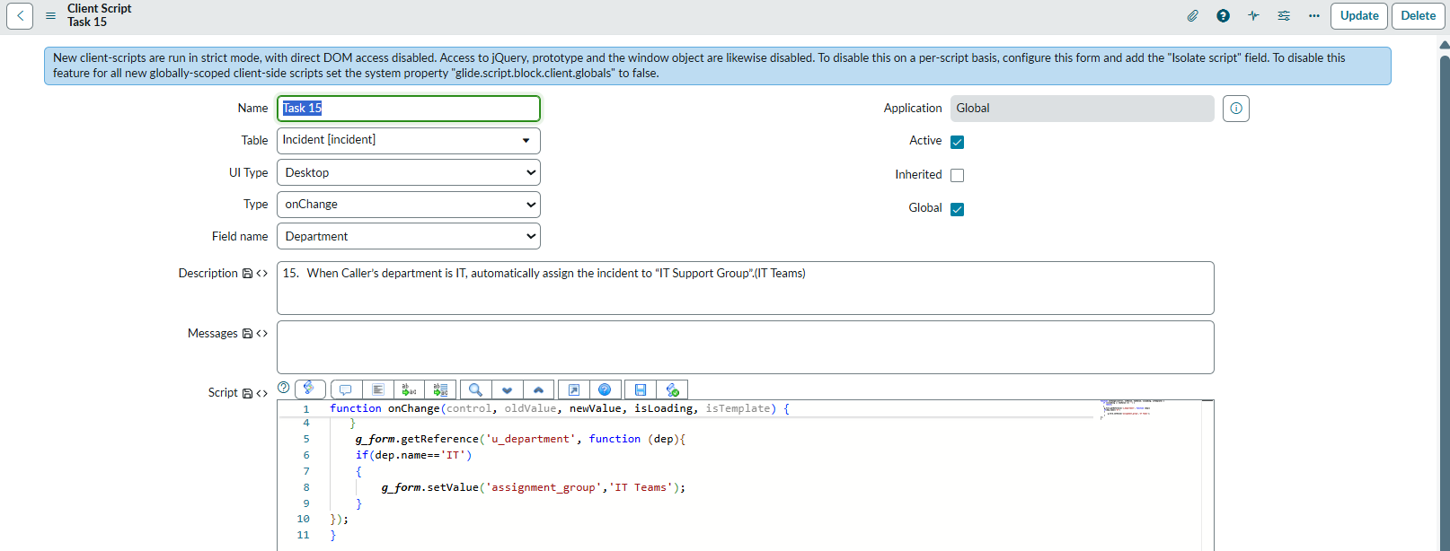

Task 16 (Advanced)
Combine Caller Name + Category and auto-fill in Short Description

Task 17 (Advanced)
If Impact = High and Urgency = High, show a warning message: “Critical Incident”.

Task 18 (Advanced)
When Assignment Group is selected, make Assigned To mandatory

Task 19 (Advanced)
If Caller location is India, set State = New automatically

Task 20 (Advanced)
When user tries to submit without selecting Category, block submission with alert

